Stomach Anatomy

Prereading

Bricks in the platform.

Learning Objectives

After completing this brick, you will be able to:

* Learning objective 1
* Learning objective 2
* Learning objective …

Case Connection

What is [Title of Brick]?

It is a large, muscular, and hollow organ allowing for a capacity to hold food. It is comprised of 4 main regions, the cardia, fundus, body, and pylorus.

The cardia is connected to the esophagus and is where the food first enters the stomach. Followed by the fundus is the body or the main, largest portion of the stomach. Following the body is the pylorus, which conically funnels food into the duodenum, or upper portion of the small intestine. The stomach is located in the human body left of the midline and centrally in the upper area of the abdomen. Blood Supply and Lymphatics The stomach is an organ which requires a rich supply of blood as it is an area which is highly mobile and distensible, is composed of 5 different cell types functioning at high metabolic rates, and has multiple muscle layers to facilitate the stomach waves of brisk peristalsis for the second phase of digestion. The RGA then runs from right to left across the lesser curved portion of the stomach and continues to branch into smaller vessels through the body of the stomach to join the network of smaller arteries supplying the stomach as branched off from the LGA. The left gastroepiploic (gastroomental) artery (LGEA) branches from the splenic artery and also supplies the greater curvature body portion of the stomach, except beginning on the left side and moving and branch in the rightward direction. The trunks also follow the lesser curvature region of the stomach to form the posterior and anterior gastric nerves of Latarjet innervating the body, antrum, and pylorus. Muscles The stomach is heavily comprised of muscle tissue, arranged in 3 layers, running longitudinally, obliquely, and circularly as part of the stomach wall. Before the muscular structure of the stomach can be understood, it is first important to understand the different layers of the stomach wall. Together, the submucosa supports the mucosal layer and has many folds analogous to that of an accordion called rugae which allows for distension of these layers when food enters the stomach. The middle circular layer is concentric with the stomach’s longitudinal axis and thickens in the region of the pylorus to form the pyloric sphincter responsible for regulating the output from the stomach into the duodenum. Surgical Considerations Some issues of the stomach may require surgery. Most issues of the stomach, when detected early enough, can be treated to avert the greater destruction of the organ or the patient as a whole. The stomach is a primary digestive organ and an important step in the delivery route of food to the duodenum. These issues are of clinical significance. To remedy many of these issues, where surgery is not needed, various medications are used to target the causes of these issues. Motility agents may also be administered to aid stomach muscular contractions and antibiotics may also be used to fight infections of the stomach such as those caused by Helicobacter pylori. PDQ Cancer Information Summaries [Internet]. StatPearls [Internet]. StatPearls Publishing; Treasure Island (FL): Jun 21, 2022.

Structure[] In the , the stomach lies between the  and the  (the first part of the ). It is in the  of the . Two  keep the contents of the stomach contained; the  (found in the cardiac region), at the junction of the esophagus and stomach, and the  at the junction of the stomach with the duodenum. Schematic image of the blood supply to the human stomach:  and ,  and  and . The gastrointestinal wall of the human stomach. The inner part of the lining of the stomach, the , consists of an outer layer of , a , and a thin layer of  called the . It consists of three layers of muscular fibres, with fibres lying at angles to each other. It is the only layer of the three which is not seen in other parts of the . The middle circular layer: At this layer, the  is surrounded by a thick circular muscular wall, which is normally tonically constricted, forming a functional (if not anatomically discrete) pyloric , which controls the movement of  into the . The mucosa lining the stomach is lined with a number of these pits, which receive gastric juice, secreted by between 2 and 7 . The corresponding specific proteins expressed in stomach are mainly involved in creating a suitable environment for handling the digestion of food for uptake of nutrients. Over time, these arteries consolidate into the three main arteries that supply the developing gastrointestinal tract: the , , and . Sections of this gut begin to differentiate into the organs of the gastrointestinal tract, and the esophagus, and stomach form from the foregut.

To a small extent water-soluble  (most are absorbed in the small intestine) The  of the human stomach are responsible for producing , which is necessary for the absorption of . Emptying of stomach chyme into the duodenum through the pyloric sphincter. Chyme from the stomach is slowly released into the  through coordinated  and opening of the pyloric sphincter. While the intestine is full and still digesting food, the stomach acts as storage for food. Other[] Effects of EGF (EGF) results in cellular proliferation, differentiation, and survival. Another method of examination of the stomach, is the use of an . A  may be placed around the cardia area, which can adjust to limit intake. "Cardiectomy" is a term that is also used to describe the removal of the . is stomach surgery in which the fundus is wrapped around the lower esophagus and stitched into place. Etymology[] The word stomach is derived from the  stomachus which has roots from the  word stomachos (στόμαχος), ultimately from stoma (στόμα), "mouth". The gastric lining is usually divided into two regions, an anterior portion lined by fundic glands and a posterior portion lined with pyloric glands. In  there is also a crop.

Header for Learning Objective 1?

Narrative text

## Header 2

Narrative text

**Header 3.** Narrative text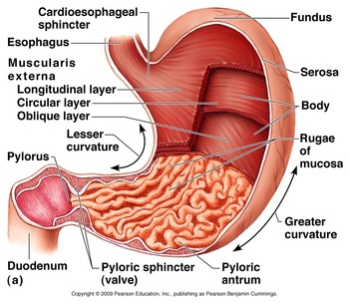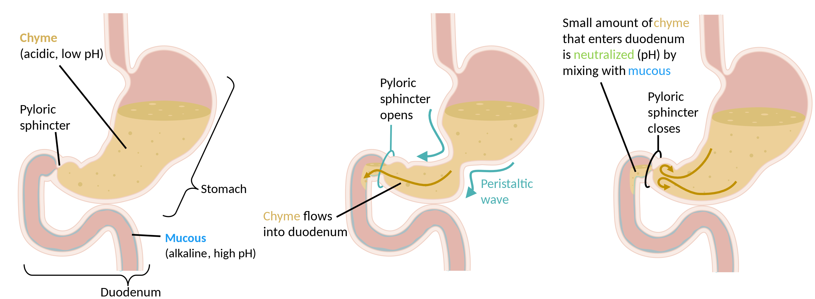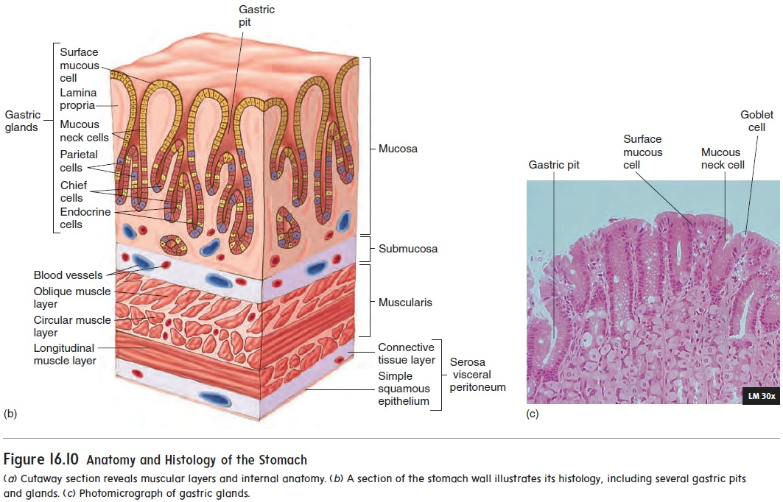

Figure 1 Short descriptive title

Q: [insert question]

A: [paragraph with the answer]

Other pedagogical elements

Case Connection

Summary

## Header for learning objective 1

* Summary point 1
* Summary point 2
* Summary point…

## Header for learning objective 2

Review Questions

1. Question 1

1. Option A
2. Option B (Correct answer)
3. Option C
4. Option D
5. Option E

2. Question 2

1. Option A
2. Option B (Correct answer)
3. Option C
4. Option D
5. Option E

3. Question 3

1. Option A
2. Option B (Correct answer)
3. Option C
4. Option D
5. Option E

Answers

1. Explanation of review question 1

2. Explanation of review question 2

3. Explanation of review question 3

**References**

**Figures**

Provide additional information about your images/illustrations here (CDN number, or if you want something drawn provide an example image here.)

|  |  |  |  |
| --- | --- | --- | --- |
| **ARTWORK** | | | |
| **Fig #** | **Description of Figure** | **Figure Source (CDN #, link, or citation)**  **\*\*Search the DAM first!\*\*** | **Modifications to Figure (if any) --**  **Detailed instructions to Art Team** |
|  | *EXAMPLES:* |  |  |
| *Fig 1* | *Cardiac conduction system* | *DAM CDN 13339* | * Delete action potentials on right side of image * Keep the rest of the texts and labels the same * Redraw the image as is in this example, keeping similar colors |
| *Fig 2* | *Pacemaker action potential* | *DAM CDN 13345* | * Add labels to graph as shown in brick |
| *Fig 3* | *Two AV nodal pathways & re-entry circuit* | *http://www.washingtonhra.com/arrhythmias/av-nodal-reentrant-tachycardia-avnrt.php* | * Pick up or redraw out of copyright |
|  |  |  |  |
|  |  |  |  |
|  |  |  |  |
|  |  |  |  |
|  |  |  |  |